ComicCraft - AI Comic Story Creator using Gemini Models
Project Description:
ComicCraft is a web-based application that uses AI to generate personalized comic book stories and illustrations based on user-provided prompts. Built with FastAPI and integrated with Google’s Gemini AI models along with Stable Diffusion, ComicCraft streamlines the creative process of generating storylines, dialogues, and vivid comic-style imagery automatically. The application takes in user information—such as story prompt, main character name, setting, tone, and art style—and generates a panel-by-panel storyline and corresponding illustrations. Users can view the comic preview directly on the web interface and also download the full comic in PDF format, structured with both images and narration. With a clean, interactive HTML interface and efficient image generation powered by Hugging Face’s Diffusers library, ComicCraft ensures that each story feels cohesive and visually engaging. It offers both API endpoints and an intuitive frontend for ease of use, making comic creation accessible even to non-artists and casual users.
Scenarios:
Scenario 1 : A user enters a prompt describing their comic story, such as “A brave fox exploring an enchanted forest.” The system uses this input to generate a complete comic strip, including multiple panels with accompanying images and text. The user also specifies preferences like the main character’s name, the setting (e.g., forest), tone (e.g., dramatic), and art style (e.g., anime). The system combines Gemini 1.5 Pro for story generation and Stable Diffusion for image creation to produce a visually immersive, personalized comic strip. This personalized approach enhances user satisfaction by generating a cohesive comic story that fits the user’s creative vision.
Scenario 2: A user wants a light-hearted, cartoonish feel for their comic. On the input form, they select “funny” as the tone and “comic book” as the art style (instead of the default or their previous choices). When they submit, the system regenerates the entire pipeline—outline, story, and images—this time with prompts and model instructions tailored to produce a more humorous narrative and a classic comic-book look. This lets users iterate on and customize the mood and visual style of their comic until it matches their creative vision
Scenario 3: After reviewing the on-screen preview of their comic, the user decides to download it. The system then
1. Layout Binding:
Model Evaluation Research documentation and capabilities of: ● Google's Gemini Models: Gemini Flash (optimized for fast structured outputs) and Gemini Pro (optimized for detailed, creative text generation). ● Hugging Face Diffusers: Stable Diffusion model (for high-quality AI-generated images based on prompts). Compare the selected models based on: ● Response quality for creative writing tasks (narration and dialogues) ● Prompt adherence and richness of detail for scene descriptions ● Speed and resolution of image generation ● Model stability, available documentation, and community support Practical testing was conducted using different prompts to assess each model's storytelling abilities and image generation performancdef build_comic_layout(image_paths: list, full_story: str, outline: list) -> list:
"""Organizes generated images, full story narration, and panel outlines

into a structured layout list for template rendering and PDF export.

Args:
image_paths (list): List of file paths to generated panel images.
full_story (str): Complete story generated by Gemini Pro formatted with
panel markers.
outline (list): List of panel dictionaries containing metadata (titles,
descriptions).

Returns:
list: Structured list of dictionaries containing panel details.
"""
# Split the full story string into individual panel segments
raw_story_panels = full_story.split("**Panel")
story_panels = [
f"**Panel {panel}" for panel in raw_story_panels if panel.strip()
]

layout = []

# Iterate over zip to combine image paths, panel story segments, and outline details
for idx, (image, text, panel_info) in enumerate(
zip(image_paths, story_panels, outline), start=1
):
# Extract narration text lines excluding the panel title header line
story_lines = text.strip().splitlines()
cleaned_text = (
"\n".join(story_lines[1:]).strip()
if len(story_lines) > 1
else text.strip()
)

layout.append({
"panel": idx,
"title": panel_info.get("title", f"Panel {idx}"),
"image_path": image,
"text": cleaned_text,
"scene_description": panel_info.get("scene_description", ""),
})

return layout
PDF Generation:
import os
from datetime import datetime
from fpdf import FPDF

# Directory configuration for exported PDFs
EXPORT_FOLDER = os.path.join("static", "exports")
FONT_PATH = os.path.join("fonts", "DejaVuSans.ttf") # Path to Unicode TTF font

class PDF(FPDF):
def header(self):
self.set_font("Dejavu", "", 10)
self.cell(0, 10, "ComicCraft - Generated AI Comic", ln=True, align="R")

def footer(self):
self.set_y(-15)
self.set_font("Dejavu", "", 9)
self.cell(0, 10, f"Page {self.page_no()}", align="C")

def save_pdf(layout: list) -> str:
"""Compiles the full comic layout into a multi-page PDF document using FPDF.

Args:
layout (list): List of dictionaries containing panel info (panel number,
title, image_path, text).

Returns:
str: The saved PDF file path.
"""
os.makedirs(EXPORT_FOLDER, exist_ok=True)

pdf = PDF()
pdf.set_auto_page_break(auto=True, margin=15)

# Register Unicode font if available, fallback to Standard font
if os.path.exists(FONT_PATH):
pdf.add_font("Dejavu", "", FONT_PATH, uni=True)
font_family = "Dejavu"
else:
font_family = "Arial"

for panel in layout:
panel_num = panel.get("panel", 1)
panel_title = panel.get("title", f"Panel {panel_num}")
image_path = panel.get("image_path", "")
story_text = panel.get("text", "")

pdf.add_page()

# Panel Header Title
pdf.set_font(font_family, "", 14)
pdf.cell(0, 10, f"Panel {panel_num}: {panel_title}", ln=True, align="C")
pdf.ln(5)

# Image placement parameters
y_image = pdf.get_y()
image_height = 100
spacing_after_image = 15

if image_path and os.path.exists(image_path):
# Center image with side margins of 10 units
pdf.image(
image_path, x=10, y=y_image, w=pdf.w - 20, h=image_height
)
else:
pdf.set_y(y_image)
pdf.set_font(font_family, "", 11)
pdf.multi_cell(
0, 10, f"[Image missing or rendering failed: {image_path}]"
)

# Text placement below image
pdf.set_y(y_image + image_height + spacing_after_image)
pdf.set_font(font_family, "", 11)

# Clean title headers inside narration lines if present
story_lines = story_text.strip().splitlines()
if story_lines and story_lines[0].strip().lower().startswith("**panel"):
story_lines = story_lines[1:]

cleaned_text = "\n".join(story_lines).strip()
pdf.multi_cell(0, 8, cleaned_text)

# Generate timestamped filename and save
timestamp = datetime.now().strftime("%Y%m%d%H%M%S")
filename = f"comic_{timestamp}.pdf"
pdf_path = os.path.join(EXPORT_FOLDER, filename)

pdf.output(pdf_path)
return pdf_path
3. Export Success: The user is redirected to an export success page, confirming the successful download. This feature ensures users can save, print, or share their comic in a professional PDF format.
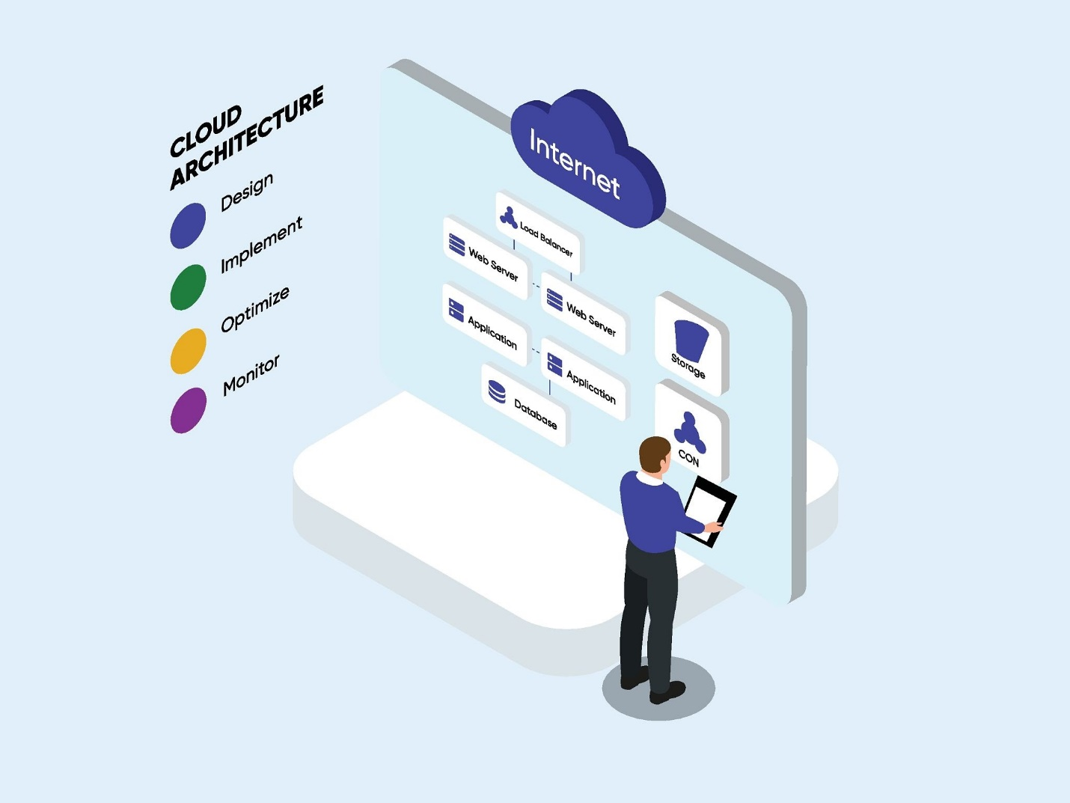
Project Workflow: Milestone 1. Model selection and Architecture Activity 1.1. Research and Select the Appropriate Generative AI Model Activity 1.2. Define the architecture of the application Activity 1.3. Set up the development Environment Milestone 2. Core functionalities Development Activity 2.1. Develop the core functionalities Activity 2.2. Implement the Fast API Backend to Manage Routing and User Input Processing 3. route.py Development Activity 3.1. Writing the Main Application Logic in routes.py Milestone 4. Frontend Development Activity 4.1. Designing and Developing User Interface Activity 4.2. Creating Dynamic Templates with Fast Api’s Jinja2 Milestone 5. Deployment Activity 5.1. Preparing the Application for Local Deployment Activity 5.2. Testing and Verifying Local Deployment
Milestone 1. Model selection and Architecture
In this milestone, we focus on selecting appropriate generative AI models for the Comic Craft application. This involves researching the capabilities and performance of multiple AI models to ensure that the chosen models align well with the application's objectives of generating comic storylines, character dialogues, scene descriptions, and comic-style illustrations.
Activity 1.1: Research and Select the Appropriate Generative AI Model
Understand the Project Requirements
Review the specific needs of the Comic Craft application, focusing on the types of content it must generate:
- Structured comic outlines (panel-by-panel) Full comic narration and character dialogues ● Visual comic-style illustrations for each panel
The system must deliver creative, engaging, and visually rich comic outputs for users based on their custom story prompts.
Model Evaluation Research documentation and capabilities of: ● Google's Gemini Models: Gemini Flash (optimized for fast structured outputs) and Gemini Pro (optimized for detailed, creative text generation). ● Hugging Face Diffusers: Stable Diffusion model (for high-quality AI-generated images based on prompts). Compare the selected models based on: ● Response quality for creative writing tasks (narration and dialogues) ● Prompt adherence and richness of detail for scene descriptions ● Speed and resolution of image generation ● Model stability, available documentation, and community support Practical testing was conducted using different prompts to assess each model's storytelling abilities and image generation performance

